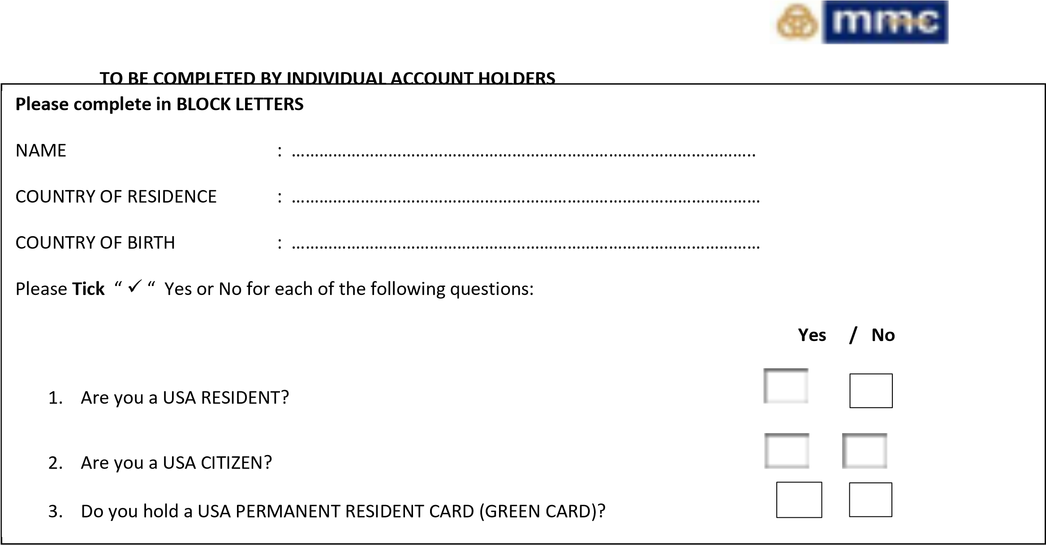
I hereby confirm the information provided above is true, accurate and complete.
- If answered yes on any of the questions: I hereby consent to MMC STOCKBROKERS or any of its affiliates to share my information with domestic or overseas regulators or tax authorities where necessary to establish my tax liability in any jurisdiction.
- Where required by domestic or overseas regulators or tax authorities, I consent and agree that the Bank may withhold from my account (s) such amounts as may be required according to applicable laws, regulations and directives.
I undertake to notify the Bank within 30 days of any change in information which I have provided to the Bank.
CUSTOMER SIGNATURE : ……………………………………………………………….
DATE : ………………………………………………………………
FOR OFFICIAL USE ONLY
Date Received Signature verified by Manager/Officer

